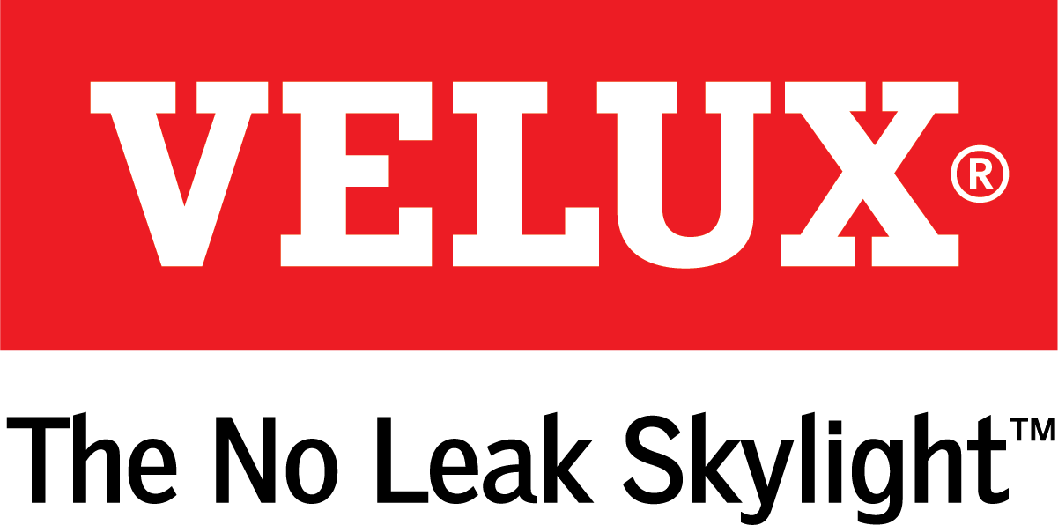
Media Contacts:
Kelsey Webb
704-790-1560
kwebb@wrayward.com

Dana Haydock
704-926-1301
dhaydock@wrayward.com

WHOLE-HOME NATURAL VENTILATION SOLUTION FROM VELUX

MEETS GROWING DEMAND FOR HEALTHY HOMES
VELUX to Present Natural Home Airing Learning Session at the
IBS High Performance Building Zone

LAS VEGAS, Jan. 21-23, 2020 – With consumers increasingly aware of the perils of polluted indoor air, VELUX Skylights offers a whole-home natural ventilation solution designed to improve the health of indoor living spaces. Join VELUX for a learning session called “Using Skylights to Improve Indoor Air Quality” at 2:30 pm PST, Jan. 22 at the High Performance Building Zone (N135, N145).
According to the U.S. Environmental Protection Agency (EPA), on average people spend 90% of their time indoors¹, while homes are built tighter for energy efficiency, trapping harmful pollutants inside. The result is that indoor air can be up to five times more polluted than outdoor air². Consumer awareness of this problem is growing, according to a survey by the Joint Center for Housing Studies of Harvard University³: 42% of households ages 25–34 have healthy housing concerns, while 37% of families with children share the same sentiments. Nearly 75% of households surveyed listed indoor air quality as the factor that best describes their concern about the impact of their home on the household’s health.
“With a growing body of evidence about the health implications of poor indoor air quality, especially on asthma and allergy sufferers, natural home ventilation is gaining prominence as one part of a healthy home design strategy,” said Ross Vandermark, national product manager for VELUX America. “Many homeowners are unaware that standard HVAC systems recycle indoor air, rather than replacing it with fresh air. Adding ventilating skylights that open periodically throughout the day can improve indoor air quality.”
Rooms like bathrooms and kitchens are especially vulnerable. According to the Harvard T.H. Chan School of Public Health, “particle levels while cooking with an unvented stove can reach 10 times higher than our health-based limits for outdoor air pollution, and they can linger indoors for hours.”
Including skylights that open on construction and renovation plans allows for not only natural light but fresh air ventilation that helps rid indoor air of pollutants from daily activities, like cooking, cleaning and bathing. VELUX No Leak Solar Powered “Fresh Air” Skylights equipped with a VELUX ACTIVE with NETATMO automation system provide the natural ventilation needed to rid indoor air of bacteria, volatile organic compounds and CO2, and serve as part of an overall strategy to make indoor living environments healthier.

# # #

VELUX is the world leader in skylights and roof windows and is one of the strongest brands in the global building materials sector. VELUX products are available nationwide through home centers, building material suppliers, lumberyards and independent door, window or roofing retailers. Consumers can locate local suppliers and installers and access information on skylight selection and the benefits of bringing more natural light and fresh air into the home by visiting www.veluxusa.com or www.whyskylights.com. VELUX skylights are made in America in Greenwood, South Carolina.

¹ US Environmental Protection Agency
² US Environmental Protection Agency – Importance of Indoor Air Quality
³ Joint Center for Housing Studies of Harvard University, Healthy Home Remodeling: Consumer Trends and Contractor Preparedness

